OVLP Academic Year 2025-26
Duration: March 30 – April 3, 2026 |  |  | Grade: Pre-Nursery |  | Subjects: All
Term III |  |  |  | Week: 5
 | English | Urdu |  | Math |  | HCD | IT
Links | class story  The Dark Forest The Little Firefly  https://drive.google.com/file/d/1L9pUorlMogVSLUpbl2MxG3qFKdzqsfCA/view?usp=sharing  The Kind Farmer and the Clever Cow  https://drive.google.com/file/d/1PjpGDXqaMBzFycjlhqpkM_y4mYPm-Kwf/view?usp=sharing  Letter u  https://drive.google.com/file/d/16gT-5-YGsKgostrKDHbHrvBsTXi_tmGN/view?usp=share_link  Reading Letter u  https://drive.google.com/file/d/1Fz45cGVm3b9ojTox61sVOOsj-0q6ypEl/view?usp=sharing | Class story  Murghi or chiriya  https://drive.google.com/file/d/1l1Gdko6TYpm5cb6e8JHlenTX2PK9_s5h/view?usp=sharing  Bhalu ka bacha  https://drive.google.com/file/d/1ncUv2pL3RmwAOLrY5lHQ84rCgscjfDzj/view?usp=sharing  Ont or Saya  https://drive.google.com/file/d/1kickcOMQo0xpV-bJFEhDATb68gkuEENC/view?usp=sharing  Harf swaad.  https://drive.google.com/file/d/1z6CsAWzM2HwSD3paT7cr8vsBt3M1eisy/view?usp=share_link  Reading Harf swaad.  https://drive.google.com/file/d/1v9NfPWla7rE4R9aLmclhEHBgo4b9O4jC/view?usp=sharing |  | Number 20.  https://drive.google.com/file/d/1jhaLMgHOgsk3vEhRJAuOmuqeWMoswNHn/view?usp=sharing  Reading Number 20.  https://drive.google.com/file/d/1CGZo4t7TyvTQ4BWnTkdfkqynbfWzcUUl/view?usp=sharing |  | P.N TIIISRP5 | Week 5 OVLP Grade Pre-Nursery IT Term 3.mp4
Day 1  C.W | - Writing ‘u’.  - Draw a picture with letter ‘u’ (up ,umbrella or utensils).  - Note book pg. # 8 | 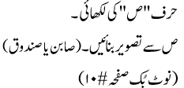 |  |  |  | Pupils will learn about Teamwork/Fruits Revise previous work
Home work | - Writing ‘u’.  - Draw a picture with letter ‘u’ (up, umbrella or utensils).  Note book pg. # 9 | ____________ |  | _____________ |  | ----------------
Day 2  C.W | Reading letter u | 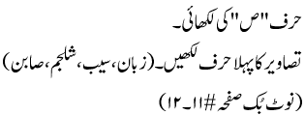 |  | - Write number 20.  - Fill in the blanks (0 – 20)  - Circle more objects.  - Note book pg. # 7-8 |  | Pupils will learn about food of the week is Grapes
Home work | - Writing ‘u’.  - Draw a picture with letter ‘u’ (up, umbrella or utensils).  - Note book pg. # 9 | 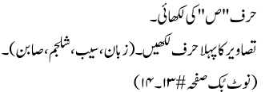 |  | _____________ |  | -----------------------
 | April 1-3 Reinforcement days

